

**Department of Artificial Intelligence**

**College of Computer Science and Information Technology**

1. **Objectives**

This lab is designed to achieve the following goals:

1. Get an introduction about machine learning.
2. Installing Python and Anaconda.
3. Get familiar with Anaconda and Jupyter notebook.
4. Introducing NumPy and Pandas.
5. **Introduction to Machine learning**

Machine Learning is a field of artificial intelligence that enables computers to learn from data and make decisions or predictions without being explicitly programmed to perform a specific task. Instead of relying on hard-coded rules, machine learning algorithms identify patterns in data and use these patterns to make informed decisions.

**How can you build a machine learning model?**

To build a machine learning model, you start by defining the problem and collecting relevant data. Next, you clean and prepare the data by handling missing values and converting it into a suitable format. Then, you choose a machine learning algorithm (e.g., decision trees, linear regression) based on the problem type and split the data into training and testing sets. The model is trained on the training set to learn patterns and relationships, and then it is evaluated on the testing set using metrics like accuracy or mean squared error. If the model's performance is unsatisfactory, you adjust its hyperparameters or try a different algorithm to improve it. Once the model is optimized and validated, it is deployed to make predictions on new data and continuously monitored for performance, retraining it as needed to ensure accuracy over time.

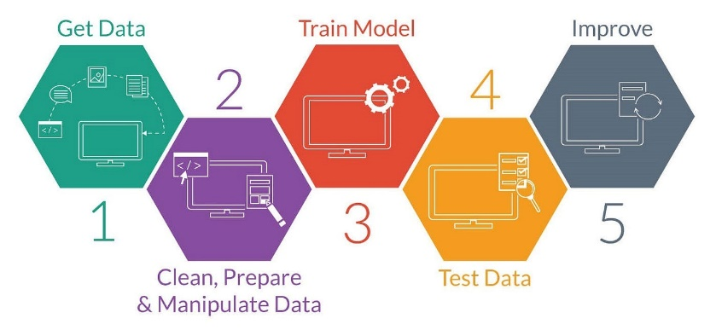

Before diving into the world of machine learning, we need to set up our working environment. We will be using **Python** as our primary programming language, along with several libraries and tools that are standard in the field.

1. **Installing python and jupyter notebook**

**Step 1: Install Anaconda**

**Anaconda** is a popular distribution of Python that includes large number of packages that are commonly used for data science and machine learning. It is a convenient way to set up your environment without having to install each package individually.

Open your browser and go to Anaconda website (<https://www.anaconda.com/download/success>) to download and install Anaconda. You will see a page like this. Click on download. Downloading will start immediately.

**Step 2:** If you have Mac, then you can scroll down to see all Anaconda Installers. Click “64-Bit (Apple silicon) Graphical Installer” under Python 3.12 version to start downloading the package file.

**Step 3:** The installer will start downloading the file (this may take a while) and will appear in top right of your browser (if you are using google chrome) as shown below.

**Step 4:** When the file is completely downloaded, go to your downloads folder, and click on the executable file. You will see that following window appears. Click on ‘Next’ button.

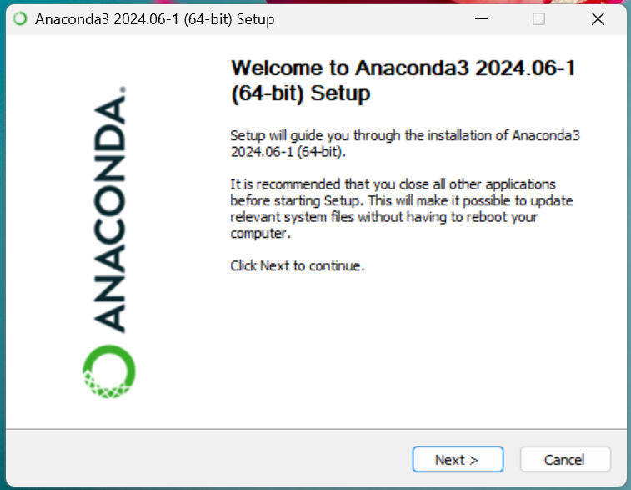

A new window will appear asking you to accept the terms of agreement, select “I Agree”.

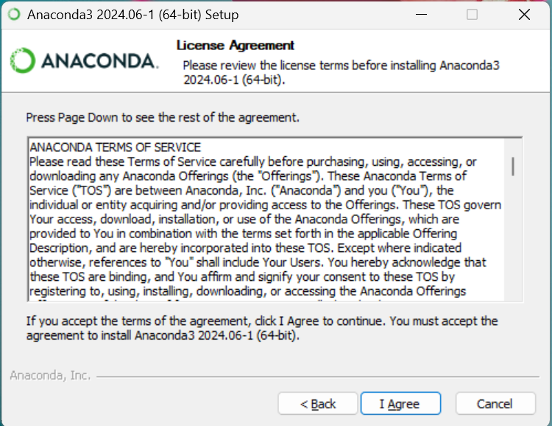

Select ‘Just Me’ which is recommended and then click Next.

**Step 5:** Make sure you have the required free space for software installation. which you can check as shown below. Then click Next. (If you don’t have required space, then you need to delete some of your items to free the space).

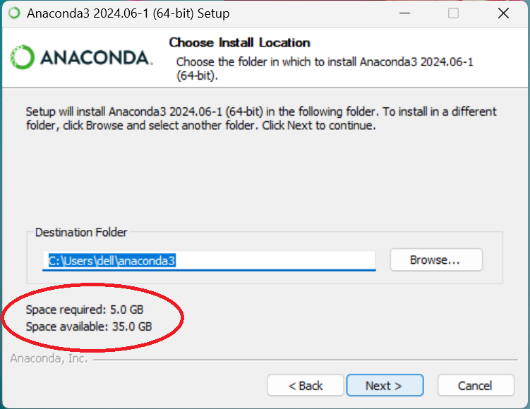

**Step 6:** You will see the following window appears. Click on Install.

This will lead you to installation page showing the progress of installation. It will take some time for the software to get installed.

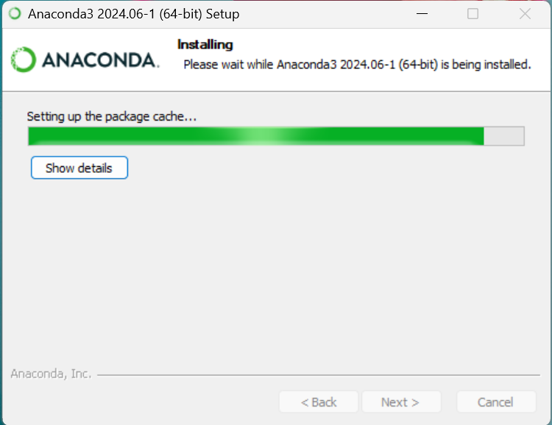

**Step 7:** After all the files are extracted, the “Next” button will get enabled. Click on Next button

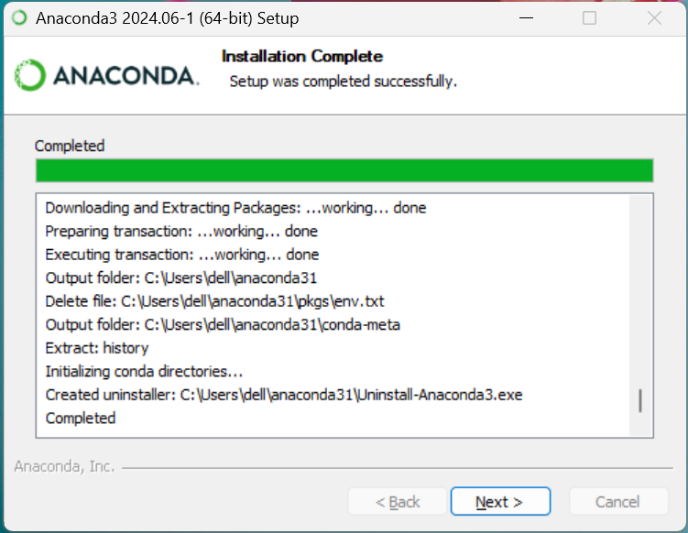

Then the following window will appear. Click on Next.

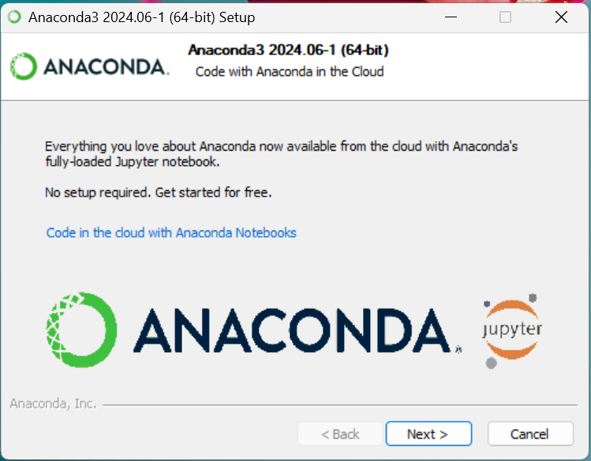

Then the following window will appear. Click on Finish button to complete the installation. Now Anaconda has been installed on your computer.

**Step 8:** Type ‘anaconda’ in search box and click on the icon indicated below.

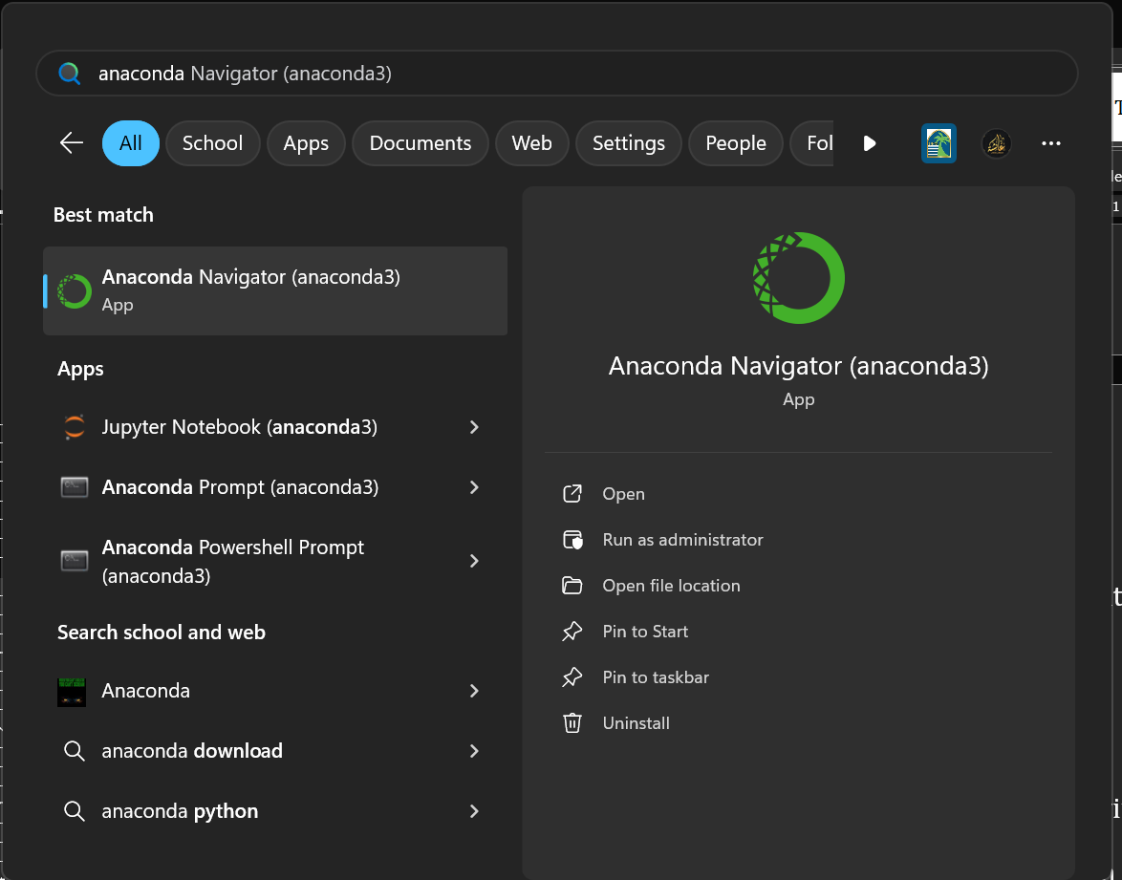

Wait for a moment and Anaconda Navigator will open.

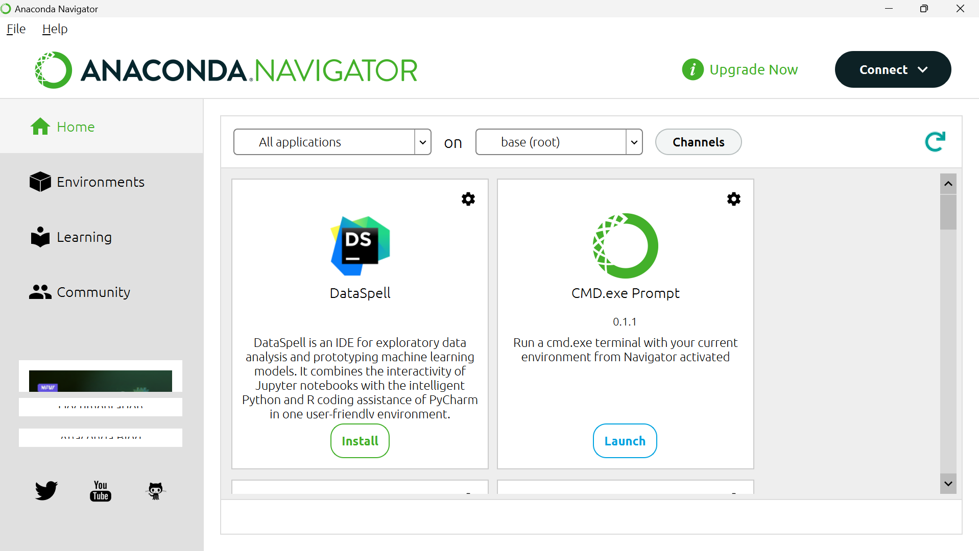

**Step 9:** Scroll down until you see ‘Jupyter Notebook’, then click on launch button.

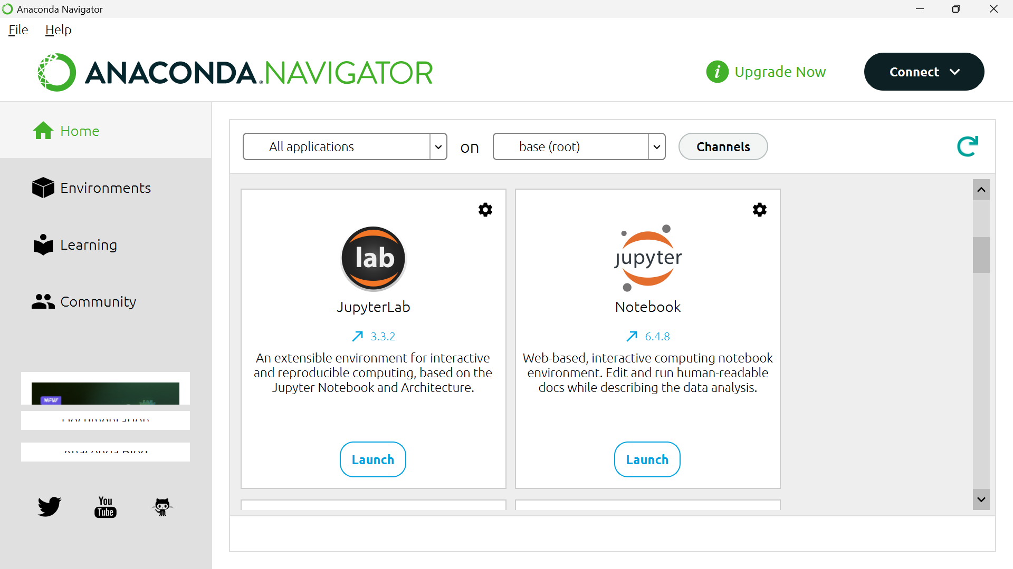

You will see that your browser opens showing Jupyter Notebook Interface. Click on “New” located at upper right corner if you wish to open Jupyter Notebook.

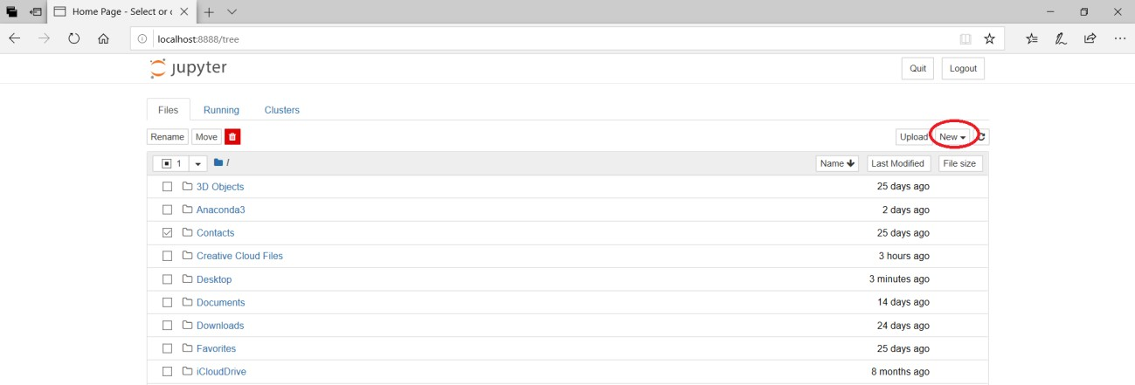

This will open Jupyter Notebook in another tab as shown below

